GENERAL PAEDIATRIC SURGERY FOR GENERAL SURGEONS AND UROLOGISTS

A Royal College of Surgeons of England Accredited Course  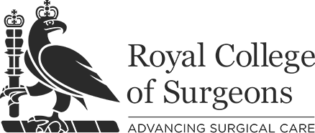 | Approved by the British Association of Paediatric Surgeons

East Midlands Conference Centre
University of Nottingham

5th July 2019

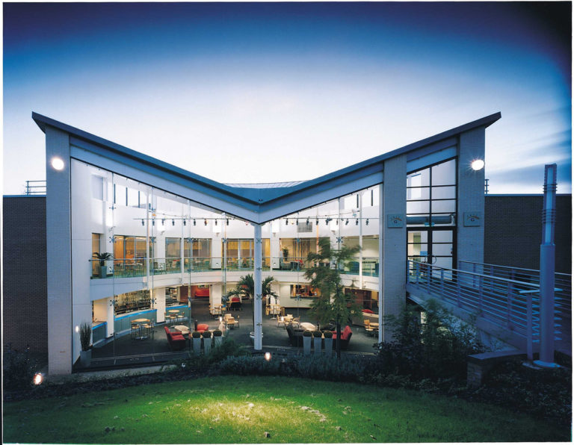

Previously called Common Elective and Acute Problems in the General Surgery of Childhood.
The course has previously been run for many years at the Royal College of Surgeons of England and in Oxford.

This year’s course is being held in conjunction with the annual Scientific Congress of the British Association of Paediatric Surgeons

There will be a combined session on Transitional Care but the main part of the course will concentrate on interactive case-based discussion of the common acute and elective conditions seen in children in District General and Rural Hospital settings.

Delegates may also choose to attend some of the main BAPS meeting on the Wednesday and Thursday and are invited to the Gala Dinner of the BAPS Congress on Thursday (normal registration rates apply).

Details of the Congress are available here:

https://congress.baps.org.uk

Aims

Provide participants with the knowledge and skills needed to establish and maintain a high quality and safe practice as a District General Hospital surgeon with a sub-specialty interest in the general surgery of children.

Provide a useful update for surgeons with an established practice.

Provide a forum for interaction with specialist paediatric surgeons.

Format

The emphasis is on conditions seen in District General and Rural Hospital Practice

Case-based discussion and lectures

The role of BAPS

Discussion of specific operative techniques

Time – All day
Who should attend?

Consultants and Higher Trainees in General Surgery

Consultants and Higher Trainees in Urology

Fee:

£190.00
Trainees: £170.00

The East Midlands Conference Centre is a modern development on the University of Nottingham Campus and is well placed for access by road, air and train.
Registration

Web: http://www.baps.org.uk/events/common-elective-acute-problems-general-surgery-childhood/

Email: congress@baps.org.uk

Telephone: 02074302573

Post: BAPS,
Royal College of Surgeons of England,
35-43 Lincolns Inn Fields
London
WC2A 3PE

Contact telephone number:

Place of Work:

Grade and specialty:

GMC number:
Address:

Name:

